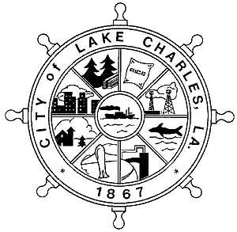

CITY OF LAKE CHARLES

PUBLIC NOTICE

The City of Lake Charles’ Community Development Department is giving notice that it will conduct a public meeting at the location listed below with the appropriate date and time.

## Location Date Time

## City Hall – Council Chambers

## 326 Pujo Street Tuesday, July 15, 2025 5:30 PM

The purpose of this meeting is for the City to receive public comment on the City’s 2025-2029 Draft Consolidated Plan which is the City’s application for Community Development Block Grant (CDBG) and Home Investment Partnership Act (HOME) funds*.*

The Draft Action Plan is available for review on the City’s website and can also be viewed at the following locations through August 5, 2025:

City of Lake Charles Transit Center Central Library

1155 Ryan Street 301 W. Claude Street

Lake Charles, LA 70601 Lake Charles, LA 70605

Community Development Department Allen August Multi-Purpose Center

326 Pujo Street, 5th Floor 2001 Moeling Street

Lake Charles, LA 70601 Lake Charles, LA 70601

**“Si usted necesita la ayuda de un traductor del idioma español**, **por favor comuníquese con la ‘La Famila Resourse Center’** **al teléfono** (337) 312-2906, **cuando menos 72 horas antes de la junta,”** which asks persons who need Spanish language assistance to make arrangements with the La Familia Resource Center on behalf of the City of Lake Charles within three days of the publication notice.

Citizens are urged to attend this public meeting to comment.

**The City of Lake Charles fully complies with Title VI of the Civil Rights Act of 1964 and related statutes and regulations in all program and activities.**

**For more information, or to obtain a Title VI Complaint Form, see the City of Lake Charles’ website--cityoflakecharles.com or call Mayor’s Action Line at (337) 491-1346, or contact the appropriate Department Head, or call the Title VI Coordinator at (337) 491-1440**