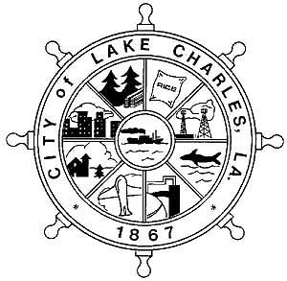

CITY OF LAKE CHARLES

PUBLIC NOTICE

The City of Lake Charles’ Community Development Department is giving notice that it will conduct a series of public hearings/neighborhood meetings at the locations listed below with the appropriate dates and times.

## Location Date Time

## City Hall – Council Chambers

## 326 Pujo Street Tuesday, May 27, 2025 1:00 PM

## Allen August Multi-Purpose Center

2001 Moeling Street Tuesday, June 3, 2025 5:30 PM

## Bellard Community Center

## 2808 Hillcrest Drive Thursday, June 5, 2025 5:30 PM

The purpose of these public hearings/neighborhood meetings will be to discuss the following:

The City’s **2025-2029 Consolidated Plan**, required by the U.S. Department of Housing and Urban Development (HUD), which will provide the framework for implementing housing and community development programs over the next five years.

The City’s **2025 Action Plan**, required by the U.S. Department of Housing and Urban Development (HUD), which will identify the specific programs and activities to be undertaken with the federal funds received annually through the CDBG and HOME grants. The Action Plan provides a framework for activities and expenditures for housing, homeless needs, and various community development issues such as public (human) services, public infrastructure and improvements.

*Special emphasis on Public Services – Information on applying for Community Development Block Grants*.

Interested organizations must be present to apply for a Public Service grant.

**“Si usted necesita la ayuda de un traductor del idioma español**, **por favor comuníquese con la ‘La Famila Resourse Center’** **al teléfono** (337) 312-2906, **cuando menos 72 horas antes de la junta,”** which asks persons who need Spanish language assistance to make arrangements with the La Familia Resource Center on behalf of the City of Lake Charles within three days of the publication notice.

Citizens are urged to attend this public meeting to comment.

**The City of Lake Charles fully complies with Title VI of the Civil Rights Act of 1964 and related statutes and regulations in all program and activities.**

**For more information, or to obtain a Title VI Complaint Form, see the City of Lake Charles’ website--cityoflakecharles.com or call Mayor’s Action Line at (337) 491-1346, or contact the appropriate Department Head, or call the Title VI Coordinator at (337) 491-1440**