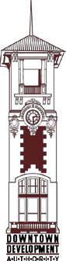

**DOWNTOWN DEVELOPMENT AUTHORITY LDS**

**CITY OF LAKE CHARLES**

**CITY COUNCIL CHAMBERS**

**CITY HALL – 326 PUJO STREET**

**MONDAY, FEB. 5, 2024 AT 5:00 PM.**

**AGENDA**

* + - 1. Call to Order
      2. Pledge of Allegiance
      3. Roll Call
      4. Approval of the Minutes DECEMBER 4, 2023 DDA Meeting
      5. Chairman’s Report:
      6. FIRST FEDERAL BANK – SIGN
      7. Adjournment

**Next Regular Meeting will be held on MARCH 4, 2024 at 5:00 p.m.**

